**Que – 5 : What is a QuerySet ? Write program to create a new Post object in database.**

**Ans-🡪 QuerySet** : QuerySet is a collection of database queries that can be used to retrieve data from a database. It's a high-level API provided by Django for interacting with databases.

* **Example :-**

1. **Models.py**

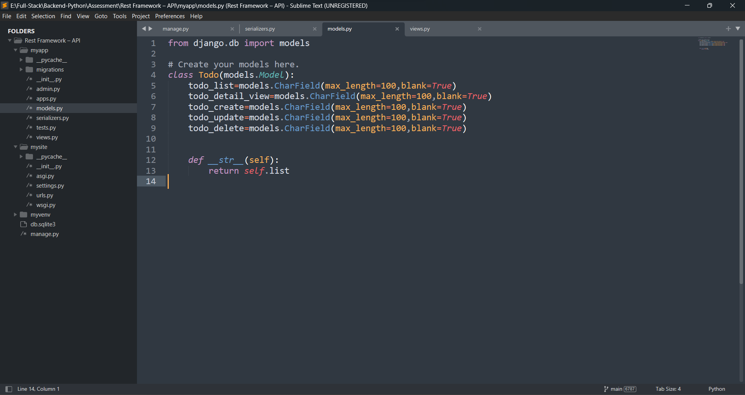

**(2)Views.py**

